The goal of the assignment is to write, implement and demonstrate using Microchip Studio 7 a C code for the AVR ATMEGA328pb microcontroller that performs the following functions:

• Read the ADC value from the POT connected to AC0/PC0. Keep displaying the voltage value UART

terminal every 0.01 sec. The resolution of the oscilloscope should be 0.1V. Use Timer auto-trigger for

this implementation.

• Using a GUI Python script, display the ADC values as waveform (using tkinter).

**Components Used/Connected**

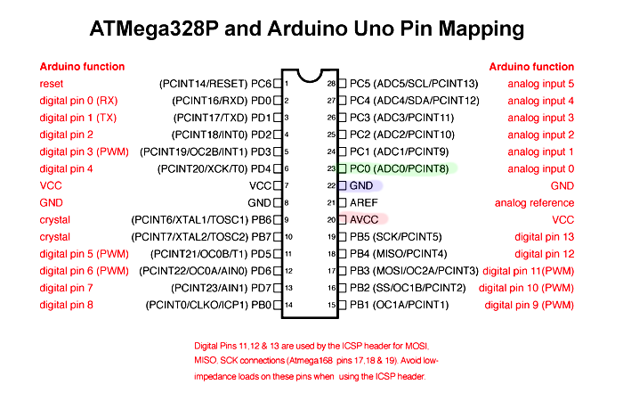

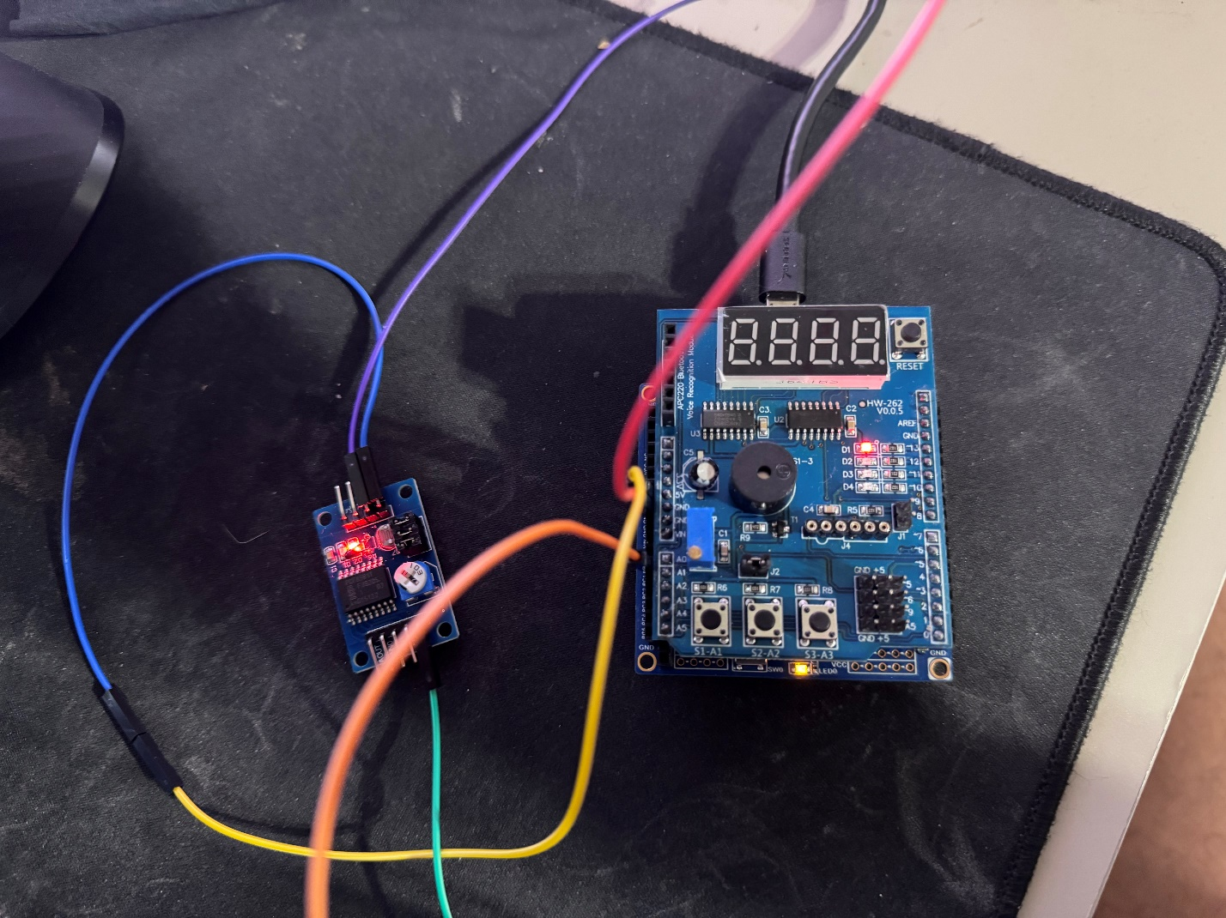

Atmega328p and potentiometer setup

Schematic. Instead of an individual potentiometer I used the PCF8591T module which had a potentiometer on it. I just had to hook up AIN3 since that’s where the voltage was read.

**AVR C Code**

/*

* DA4.c

*

* Created: 4/5/2025 6:22:31 PM

* Author : enriq

*/

#ifndef F_CPU

#define F_CPU 16000000UL

#endif

#define BAUD 9600

#define UBRR_VALUE ((F_CPU/16/BAUD) - 1)

#include <avr/io.h>

#include <avr/interrupt.h>

#include <util/delay.h>

volatile uint16_t adc_result = 0;

void uart_init() {

UBRR0H = (UBRR_VALUE >> 8);

UBRR0L = UBRR_VALUE;

UCSR0B = (1<<TXEN0);

UCSR0C = (1<<UCSZ01)|(1<<UCSZ00);

}

void uart_send(char c) {

while (!(UCSR0A & (1<<UDRE0)));

UDR0 = c;

}

void adc_init() {

ADMUX = (1<<REFS0);

ADCSRA = (1<<ADEN)|(1<<ADATE)|(1<<ADIE)|(1<<ADPS2)|(1<<ADPS1)|(1<<ADPS0); // Enable ADC, Auto Trigger, Interrupt

ADCSRB = 0x00;

DIDR0 = (1<<ADC0D);

ADCSRA |= (1<<ADSC); // Start ADC conversion

}

void timer_init() {

TCCR1B |= (1<<WGM12); // CTC Mode

OCR1A = 12499; // OCR1A = 2499; // 10ms

TCCR1B |= (1<<CS11)|(1<<CS10); // prescaler 64

TIMSK1 |= (1<<OCIE1A);

}

ISR(ADC_vect) {

adc_result = ADC;

}

ISR(TIMER1_COMPA_vect) {

uint16_t mv = (adc_result * 500) / 1023; // Convert ADC to millivolts

uart_send((mv / 10) + '0'); // Send whole number part

uart_send('.');

uart_send((mv % 10) + '0'); // Send decimal part

uart_send('\n');

}

int main(void) {

uart_init();

adc_init();

timer_init();

sei(); // set global interrupt

while (1) {

}

}

Successful Compilation

Successfully reading values from potentiometer in COM3 at 9600 Baud

Running python script. Used a generic graph template for tkinter to make the script.